Guidelines for writing seminar papers

September 2025

Dear students,

This guideline provides you with a comprehensive overview of the standards of academic writing. It includes instructions on how to design your layout, how to cite your sources and why these standards have to be met. Your academic work such as papers or theses must adhere to certain formal requirements to maintain academic integrity and quality. Proper citation of content from other authors, as well as your own previously submitted works is crucial to avoid plagiarism and self-plagiarism. By fulfilling these requirements, you will ensure your work meets high academic standards. For guidance on the quality of a journal, the VHB ranking provides good orientation: https://www.vhbonline.org/services/vhb-rating-2024.
We aim to keep this document up to date, but please inform us if any explanations are still unclear or if any links are no longer working. Your feedback is very much appreciated!
Please be aware that these are the official requirements for your thesis or paper assignment. Failure to meet them may result in point deductions. Please make sure to follow everything listed below.
Best of luck with your work! We look forward to receiving it and seeing your academic progress.

Table of contents
List of Figures 2
List of Tables 3
1. Formal Guidelines 4
1.1 Typographic Design 4
1.2 Formal Structure of the Work 4
1.3 Information on the Cover Page 5
1.4 Structure of the Table of Contents 5
1.5 Rules for Titles and Table of Contents 7
1.6 Tables and Figures 7
1.6.1 Design of Tables 8
1.6.2 Design of Figures 9
1.7 Management Summary 9
2. Content Structure 9
2.1 Content Outline 9
2.1.1 Introduction 10
2.1.2 Main Part 11
2.1.3 Discussion 12
2.1.4 Appendix 13
2.2 Language and Stylistic Expression 13
3. Transparency of Sources 13
3.1 Direct Quotations 14
3.2 Indirect (Paraphrased) Citation 15
3.3 Rules for Citing and Bibliographing Legal Documents 16
3.4 Secondary Sources 17
3.5 Source Citations for Tables and Figures 17
3.6 Footnotes 17
3.7 Citeability and Obligation to Cite 17
4. Bibliography 18
5. Plagiarism, Ghostwriting, Self-plagiarism, and use of AI 26
Appendix 1. Templates 29

List of Figures
Figure 1. Title of the Figure 9

List of Tables
Table 1. Title of the Table. 8

Formal Guidelines

Typographic Design
The main text of the paper should be written in Calibri or SourceSansPro (or a comparable font) with 11pt font size, 1.15 line spacing and as justified text. The margin should be 2.5 cm on the left and the right side as well as on the top. The bottom should be 2 cm. Between different paragraphs please set a spacing of 6pt after each paragraph and refrain from indenting the text. To facilitate your work, you can design a style, find a video with instructions here. It takes extra time at the beginning but saves you a lot of time in the long run.
Apart from the cover, all pages have to be numbered. The prelims of the paper (everything before the introduction, i.e. table of contents, list of tables and list of figures) are numbered with Roman numerals. With the beginning of the actual work (from the introduction to the last page), Arabic numerals (1, 2, 3...) are used. The List of References is numbered with roman numerals. Please do not number your Declaration of Authorship, neither the Declaration of Tools. If you have an appendix, please number it sequentially with Arabic numerals, starting from 1. See Chapter ‎6 (‎Templates) for examples and this video for instructions on how to insert page numbers.
One of the most important criteria for scientific work is the consistency of presentation. Once a style has been adopted, it must be maintained throughout your work. This refers to different areas, such as a consistent citation, numbering, use of chapter transitions or references. This can be very detailed work; we want to encourage you to pay extra attention. The thesis must be registered and submitted via OLAT. After receiving an email from your supervisor granting you access to the OLAT course, you have 24 hours to select your thesis topic. The thesis must be uploaded digitally in OLAT by the exact deadline specified in your personal OLAT workflow; late submissions will not be accepted.

Formal Structure of the Work
The contents of a paper should be arranged according to the following scheme. Please find detailed information here:
- Cover
- Table of Contents
- (List of Tables)
- (List of Figures)
- (List of Abbreviations)
- Main text
- (Appendix)
- Bibliography
- Declaration of Authorship
- Declaration of Tools

Whether the contents in brackets are necessary depends on the individual case. For example, a list of tables and figures is only necessary if there is more than one table or figure. In the list of abbreviations, care should be taken not to list abbreviations that are generally known or defined in the dictionary (i.e. "e.g.", "UNESCO"). Rather, the aim is to include abbreviations of laws, manuals, encyclopaedias, journals, offices, associations, etc. They are listed in alphabetical order.

Information on the Cover Page
The cover page must contain the following information:
- Type of the paper (e.g. term paper or thesis)
- Title of the paper
- Name, e-mail address and Student ID no. of the author(s)
- Title of the course, module number, name of the instructor and, if applicable, the supervisor of the thesis
- The semester in which the course was held
- Date of submission
See Chapter ‎6 (‎Templates) for an example of a cover page.

Structure of the Table of Contents
The table of contents is crucial to gain an overview over your paper or thesis. To facilitate the creation of your table of contents you are strongly advised to use the automatic function in word. If you used the ‘style’ function, please follow this video or this shorter video for instructions. If you are working without the automatic style function, go to references. In the left corner you will find “add text”. Choose whether you want to have a header or sub-header and it will appear in your table of contents. The table of contents is located on the second page of the document. Each section of the table of contents is accompanied by the page number where the corresponding section can be found in the main text. The table of contents must be coherent and logically structured. It reflects the "common thread" or the intellectual framework of the paper.
The individual levels of the table of contents are numbered in decimal format (1., 1.1., 1.1.1., etc.). In general, for seminar papers, the table of contents should not exceed the fourth level (e.g., 1.1.1.1). Each level must contain at least 2 subsections (e.g., 1.1, 1.2, and 1.3; or 22.1 and 2.2.2; never just 1.1 or 2.2.1). For very short sections, subheadings can also be used, but they should not be numbered and should not be included in the table of contents.

Example: Table of Contents
Table of Contents
List of Tables and Figures IV
List of Abbreviations V
Management Summary VI
- Introduction 1
  - Research Questions and Objectives 1
  - Structure of the Paper 4
- Theoretical Background 5
  - Definition of Terms 5
    - First Term 5
    - Second Term 6
  - Aspect A 8
    - First Subaspect of A 8
    - Second Subaspect of A 11
  - Aspect B 13
    - First Subaspect of B 13
    - Second Subaspect of B 15
- State of Research 18
(Subchapters)
- Further Development of the Theory 26
(Subchapters)
- Method 32
  - Research Design 34
  - Data Collection Instruments 36
  - Selection and Description of the Research Material 40
- Results 46
  - Hypothesis 1 49
  - Hypothesis 2 54
- Summary and Conclusion 60
  - Summary 60
  - Outlook 65
Appendix 67
  - Tables 67
  - Interview Guide 85
  - Transcripts of the Interviews 87
References 96

Rules for Titles and Table of Contents
Headings should not contain verbs; instead, they must be formulated as concise, noun-based phrases. Journalistic titles are to be avoided, as headings should remain factual, precise, and neutral in tone. The formatting of heading levels must be applied consistently, following a clear hierarchy (e.g., Heading 1, Heading 2, Heading 3) and using uniform styles throughout the document.

Example: List of Abbreviations
List of Abbreviations

AMA | American Marketing Association
B2B | Business-to-Business
BAG | Bundesamt für Gesundheit
BV | Bundesverfassung
CD | Corporate Design
CI | Corporate Identity
GFfK | Gesellschaft für Konsumforschung
OLS | Ordinary Least Squares
StGB | Strafgesetzbuch

Tables and Figures
Tables and figures are a good way of presenting extensive information in a clear and organized manner. It should allow the reader to quickly grasp complex data and trends that are in connection to the text. The presentation must be self-explanatory, meaning it should be immediately clear what the facts and data presented refer to. Each table and figure should include descriptive titles and relevant legends to ensure that readers can easily understand the context and significance of the information. In the description the source of the table or figure should be added. If you designed the table yourself, the source is "Source: Author's own design" or "Source: Created by the author". To add the description to the table or figure, make a right click on your table or figure and choose the option insert caption. You can choose the type of caption and add the information needed. All tables and figures are numbered with Arabic numerals. Each table and figure must be referred to and explained in the text.
When referencing the table or figure in the text, the words "table/figure" are written out in full and the numbering is indicated, e.g., "As can be seen in Table 1/Figure 1, ...". Tables and figures are inserted at appropriate places in the text, preferably directly after the section in which the illustration is referred to. Additionally, figures should be inserted “in line with text”.
It is strongly advised to use cross-references when inserting table and figure references. This ensures that numbering and titles update automatically if figures are moved, tables are deleted, or new ones are added. By selecting the entire document and pressing F9, all cross-references will refresh accordingly, saving time and reducing the risk of inconsistencies. For a step-by-step guide on how to insert and update cross-references in Microsoft Word, you can refer to this video tutorial.

Design of Tables
The table heading is placed below or above the table. The annotation below the table summarizes the explanations and the sources. In this video you can see how to implement the heading and your table of contents. To learn more about table formatting in APA, have a look here.
Tables are inserted as an image and set to "In line with text." The heading and the annotation text are placed flush with the table margins. Tables should contain vertical lines only when groups of multiple columns would otherwise not be clearly delineated. Horizontal lines are used to separate sections of meaning. If the table does not fit on one page, it is continued on the new page. The heading then says: "Continuation table x", then the table heading and the continuing values.
When including a table or figure in your academic work, ensure it is sufficiently large and rich in detail. A well-designed table or figure should be clear and readable, allowing the reader to easily grasp the data and results. Proper scaling and visible labels enhance comprehension, making it easier for readers to understand and interpret your findings. Clear and detailed visuals support your narrative and strengthen the impact of your work.

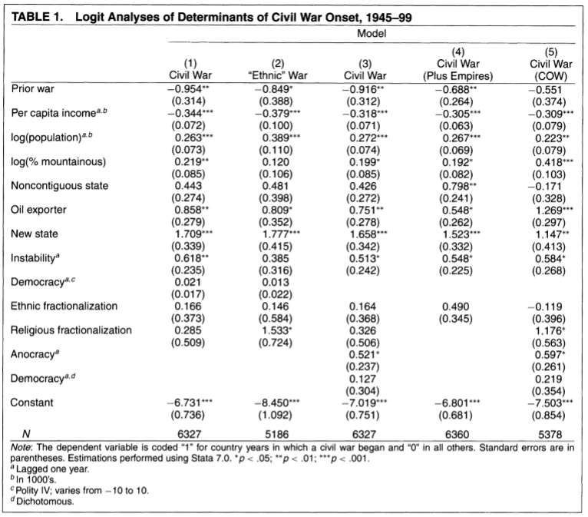
Table 1. Title of the Table.
Source: Fearon and Laitin (2003)

Design of Figures
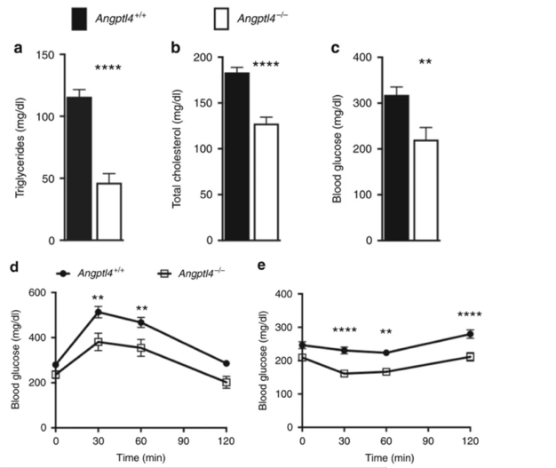
Captions should be placed above the figure. In the case of diagrams and infographics, however, explanatory texts and source information is often placed below. For the sake of standardization and ease of use, figures such as tables should be provided with a caption that is consistently placed below the figure within your work or consistently above.
Figure 1. Title of the Figure

Management Summary
The management summary is to be limited to a maximum length of one page. Its purpose is to provide a concise overview of the key objectives, findings, and recommendations of the work, enabling readers to quickly grasp the essential content without having to consult the full document.

Content Structure

Content Outline
The main text of a scholarly work generally consists of three elements: Introduction, Main Body, and Conclusion. While the functions and content elements of the introduction and conclusion apply to any form of written academic work, the structure and organization of the main body mainly depend on the methodological design, the topic, and the formal nature of the work (e.g., seminar paper or thesis). The main body is composed of several chapters of the highest level of hierarchy.
When using literature, students should exercise critical judgment: avoid over-quoting, blindly adopting theories, or relying excessively on secondary sources. The aim is to demonstrate understanding, synthesis, and independent reflection, rather than merely reproducing existing material.

Introduction
The introduction serves to introduce the content of the paper and make the reader interested in the content. It should not exceed 10% of the paper. To increase the interest in your paper you might want to refer to a current or historical event, a famous quote or present a striking statistic or fact. You want to hook your readers, learn more about how to write it here. Here you can find detailed instructions for the introduction of your essay and dissertation. This article further provides you with a step-by-step explanation.
After one sentence to build up interest, an overview of the topic should be provided. Describe the current situation and what question (your research question) arises from this. Make your research question very clear. The research question forms the starting point for your further work, you should regularly refer to it in your paper. It should serve as a criterion to decide whether an information is relevant or not. If you have struggles to find a fitting research question, this and this video might be helpful.
In a second paragraph that is still part of your introduction, you should discuss the relevance of the research question and more comprehensively present the research interest or the goal that you aim for with your research question. You should present the research already conducted in the field and where you identify a research gap. This highlights the usefulness of the study and the contribution it can make. Please make sure what you exclude from your research. In this part you should already draw the connection between the specific theory and your subject of study and how they can be connected to each other.
If needed, you might want to add a short sub-chapter about the most important terms and definitions. This is normally only needed if you write about a very specific topic with multiple terms or if you use several terms form a different language that need explanation.
After the main introducing elements, you want to prepare the reader for the main body. Therefore, present the structure. Typically, the reader is provided with a brief overview of each main heading. A common hazard is to formulate the structure very repetitively. This is again, to spark interest of the reader, so it would be unfavorable to formulate in a boring manner.

Example: Important Aspects of an Introduction
Source: Rinallo, D. & Basuroy, S. (2009). Does advertising spending influence media coverage of the advertiser? Journal of Marketing, 73, 33-46.

- Observation (What is the starting point of the investigation? What is the problem?):
Certain media regularly describe, evaluate, or recommend products and services, such as books, movies, cars, restaurants, PC accessories, fashion, etc. Frequently, the providers of these products/services are also advertisers in the media (p. 33).

- Research Question (What is the research guiding question?):
To what extent do media report neutrally on the products/services of their advertisers? (p. 33)

- Knowledge Interest / Research Objective (What insights do the authors aim to gain with the study?):
The authors aim to empirically investigate to what extent the extent of advertising of a company influences the media coverage of the products and services offered by that company (p. 33).

- Delimitation (What are the authors focusing on, and why? What exactly is to be examined?) (For the sake of clarity, without explanation here):
The authors will analyze Italian fashion companies, their advertising activities, and the media coverage of these firms in US and European magazine publishers (p. 33 f.).

- Relevance (Why is it important to address the research question?):
Among other reasons: Consumer decisions are influenced by media reports and recommendations, particularly because they appear more credible than advertising claims; hence, consumers could be deceived by biased media coverage. Additionally, the study can contribute to the question of the functioning of media in capitalist economic systems... (p. 34).

Main Part
For empirical studies that involve collecting data and using methods of empirical social research, the following structure is recommended. You can find more information here:
Chapter on Extant literature and Theory: In this section, the theoretical framework of the topic and the current state of (empirical) research on the subject are presented. Based on this foundation, the own research question can be contextualized, and hypotheses can be derived (see example "Table of Contents" in chapter 2.3).
Chapter on Method: This section provides detailed information about the design, type, and implementation of the empirical data collection. It includes specific details about the target population and sample, the data collection instruments and techniques employed, and the statistical methods and measures utilized.
Chapter on Analysis and Results: Here, the findings of the study are presented, typically following the order of the hypotheses. A more in-depth discussion of the data and its interpretation in relation to the research question and hypotheses is not conducted at this stage.
Chapter on Interpretation: In the context of data interpretation, the significance of the empirical results regarding the research question and hypotheses is explained. The individual findings are elucidated, and their implications are evaluated in terms of their importance. Discuss your findings based on the literature you already presented.
For theoretical papers without self-collected empirical data, the content structure of the main part (e.g., a seminar paper) strongly depends on the topic and research question. Due to the multitude of possible topics and research questions, a general outline that is applicable to all types of papers cannot be provided here.
In general, the individual chapters should be oriented around the central research question and the literature that was already published on the matter. Regardless of the chosen organizational principle, the main part of a theoretical work should include the following elements. This forms the so-called theoretical framework. Watch this video or read this article for more information and instructions:
- Presentation of relevant theories and concepts from the research literature
- Fundamental concepts (scientific definitions, distinctions between different concepts, and their interrelationships)
- Premises and main hypotheses of the theories and concepts, supported by empirical evidence

Discussion
In the conclusion, the findings from the individual chapters of the main part are summarized, potentially compared, related to each other, discussed, and finally evaluated in the context of the research question. Similar to the introduction, the conclusion of the paper serves an overarching function by presenting the overall context of all chapters and results. Additionally, the conclusion aims to place the own findings in relation to existing empirical data and established theories, subjecting them to a final evaluation. In this chapter you should clearly answer your research question and point out any limitations that still occur.
Conclude what kind of new insights the paper offers and what implications this has for future research. Point out if you made contradicting findings to the academic literature, you presented earlier. As you hopefully successfully addressed the research question you have identified, you can point out new questions that have occurred. Conclude by presenting further research needs.
This video will help you to understand what is asked for, alternatively try the 5Cs method explained in this article.
If you experienced major challenges that limited the success of your paper, you can state them here. Particularly if you were not able to conduct the data you needed or if there is not enough literature, mention it here. This gives the reader the opportunity to understand the limitations of your work.

Appendix
The appendix is intended for supplementary documents such as questionnaires, interview transcripts, statistical data, etc. It should provide additional topic-related information that is not necessarily essential for understanding the main body of the work. Therefore, it is not permissible to "relegate" the actual text of the paper to the appendix. Further, if extensive additional material is to be provided, it is advisable to create an appendix list (similar to the "Table of Contents") to facilitate readers' orientation.

Language and Stylistic Expression
Academic writing is characterized by objectivity. To ensure objectivity, personal pronouns like “I” or “in my opinion” as well as “we” should be avoided. As you want to primarily produce and reproduce knowledge, your personal opinions should not be given. If you struggle with personal pronouns, please have a look at this guide. Moreover, the UZH provides rules for inclusive language that you can find here. Please adhere to these rules.
It is also crucial to write in a clear and concise manner. Avoid ambiguous phrases and complex sentence structures as they might confuse the reader. Try to avoid exceeding 20 words per sentence. Particularly for definitions you want to concentrate on the right wording, as small inaccuracies can result in falsely defining a term. Avoid casual wording and overly casual expressions but maintain a formal tone. In line with this goes high preciseness of appropriate terminology. Great support can be provided by a variety of Artificial Intelligence programs, please disclose their usage in the AI tool list.
To enhance comprehensibility, it is helpful to introduce sections with short pre-texts. These are inserted directly after main headings (e.g., after the heading for "1" and before "1.1"), providing readers with an overview of the upcoming content. You should start the chapter with an introducing sentence and end it with a concluding sentence about the main aspects to take away from the section. Your sub-chapters should have a minimum length of half a page, but rather more. Always question if the presented aspect needs a sub-chapter or if it could be presented with other aspects. It can be challenging to balance comprehensibility with subsequent sections and a more pleasant reading flow.
Headers (and also table or figure captions) may either capitalize each noun or use only a capital letter at the beginning, as is standard in English. Both formats are acceptable.

Transparency of Sources
Reproducing external intellectual property is crucial for your paper. Your work and argumentation should be built on former papers that have to be clearly indicated. The readers have to be informed of the sources and where they can find the information you gave. Find more information why citation is crucial here. Both direct quotations and paraphrasing thoughts, opinions or ideas have to be cited correctly. The referencing of content and statements follows specific rules. Failure to acknowledge external intellectual property is considered plagiarism (see also “Plagiarism and Self-Plagiarism”, chapter 5)!
Use the citation style of the American Psychological Association (APA). On their website you can find additional information on specific cases that are not mentioned in this guideline, here you can find the Basic Principles of Citation. If you want to learn more about APA, check out their website or this description.
We advise you to use a reference management software. There are multiple on the market, hence you should compare different software and find the one, that meet your expectations. In this comparison, the TU München provided an overview about all programs. Here you can find the 10 best reference management software. Most of the offered software have a monthly fee, however, UZH offers some to the students for free via a university license. Make sure to check this opportunity when you settle for a software. If you need more help in finding the right software or how to work with them, please check the website of the library. They offer great services and know best which software is free for UZH students.
The biggest asset of using such a tool is that it keeps your sources organized for you. While writing your text, you can easily add the sources without misspelling any names or years. Further, it will make sure that the formatting will always adhere to the APA standards. Lastly, the software compiles your bibliography. All used sources are added automatically with all information relevant in a bibliography. In the following there are descriptions for different forms of citations. For more basic information, have a look here.

Direct Quotations
A direct quotation is when you have a word-for-word quote. The original statement and sentence are copied into your text in its entirety. You should use direct quotes sparsely and instead paraphrase the thought or finding. Any spelling and grammar errors present in the original are also retained and market with [sic] directly after the error.
When you directly quote, the author, publication year and page from which the text was taken are always provided. Particularly the page number is important because the reader must be able to understand where the quote was taken from. All the information is in brackets right after the quote, but before the final dot of the sentence. Short direct quotes with less than four lines are included directly in the running text and enclosed in quotation marks. Make sure that the quotation marks are in the English manner.
Example
Effective teams can be difficult to describe because “high performance along one domain does not translate to high performance along another” (Ervin et al., 2018, p. 470).
Nowak (2019) wrote that “people have an obligation to care for there [sic] pets” (p. 52).

Longer direct quotations of four or more lines are indented on the left. Quotation marks are omitted.
! The parenthetical citations come after the closing punctuation.
! If the quote spans two lines, you can use the key combination Strg+Shift+Space to bring it into one line.
Example
Researchers have studied how people talk to themselves:
Inner speech is a paradoxical phenomenon. It is an experience that is central to many people’s everyday lives, and yet it presents considerable challenges to any effort to study it scientifically. Nevertheless, a wide range of methodologies and approaches have combined to shed light on the subjective experience of inner speech and its cognitive and neural underpinnings. (Alderson-Day & Fernyhough, 2015, p. 957)

If there are quotation marks (“...”) within a directly quoted text, they are replaced by single quotation marks (‘...’).

Changes in Direct Quotations
Omission of words or sentences within a quote are marked with three dots, each separated by a space and enclosed in parentheses. No ellipses are inserted at the beginning or end of the quote. You can add a word to the sentence if it is needed to make the quote fit into your text. The added word has to be inserted in square brackets making it obvious that it is added.

Example
De Backer and Fisher (2012) noted that “those [adults] who read gossip magazines, watch gossip-related television shows, or read gossip articles from internet sites (. . .) may feel guilty about wasting their time on a leisure pursuit” (p. 412).

Indirect (Paraphrased) Citation
An indirect (paraphrased) citation occurs when you non-literally adopt the ideas and perspectives of an author. In indirect quoting, the author and the year are also provided in parentheses. The page number is indicated if the source does not pertain to the entire work but you only cite a specific element of the statement made. This form of quotations occurs much more often.
Example
Webster-Stratton (2016) described a case example of a 4-year-old girl who showed an insecure attachment to her mother; in working with the family dyad, the therapist focused on increasing the mother’s empathy for her child (pp. 152–153).

If a statement is supported by multiple sources, the authors are listed in alphabetical order, separated by semicolons, for example, (Bentele, 1999; Röttger, 2001).
! If the quote spans two lines, you can use the key combination Strg+Shift+Space to bring it into one line.

Further regulations for in-text citations:
When citing sources with multiple authors, special regulations apply:
- Author names are separated by commas. In parentheses, an ampersand "&" is inserted before the last author's name, while in the text, "and" is spelled out
- When citing a source with two authors, both authors are always mentioned
- Example for direct quoting: (Glaser & Strauss, 1998, p. xx)
  - Example for indirect quoting with reference to the entire work: (Glaser & Strauss, 1998).
- When citing from a source with three or more authors, only the first author's name followed by "et al." is given.
- Example for direct quoting: (Wirth et al., 2004, p. xx).
The author of a text can also be an institution or an organization.
Example
SRG was again able to generate revenues in 2000 (SRG SSR idée suisse, 2001).

When citing sources without an author, the first two to three words from the title are placed in quotation marks and followed by the year, for example: ("Smartphone and Tablet," 2016).

Rules for Citing and Bibliographing Legal Documents
There are different conventions and standards for citing or bibliographing legal documents (laws, materials, judgments, etc.). Often, for example, laws or materials (documents related to legislative work or legislative processes such as drafts, reports, consultations) are not listed in the reference list but are only cited in the text or footnotes. However, for term papers at IKMZ, every citation must be clearly traceable (including, for example, URLs) and listed in a bibliography. When citing and referencing such sources, you are allowed to choose the format, but it must be systematic and consistent.

Secondary Sources
Generally, the use of secondary sources should be avoided and only used of the original source is not accessible. When citing, the original source should be mentioned first in parentheses, followed by the secondary source with "cited in" before it. Only the secondary source appears in the reference list.
Example
(Rabbitt, 1982, as cited in Lyon et al., 2014)

Source Citations for Tables and Figures
An unchanged adoption of a table or figure must be appropriately indicated. The citation format is as follows:
Adopted from "Publication Title" by A. Author, Year, Journal Name, Volume, p. xx.
If the content and/or format of the presentation are (even slightly) modified, the phrase "Adapted from" is added.
If you generate a table/figure using text content from other authors, the original author must be cited in the corresponding section of the text that references the representation, e.g.:
Müller (2002) describes several theoretically possible relationships between the variables (see Figure 4): ....

Footnotes
Footnotes should be used sparsely. Important steps of the argumentation belong in the main text, while insignificant ones should be omitted. Footnotes are intended for adding supplementary information and explanations that might disrupt the flow of the main text, such as longer annotated references or definitions. Footnotes are placed at the bottom of the page where the note is made. They are typically formatted with a 1 to 2 point smaller font size. In the text and the footnote itself, footnotes are identified with superscript numbers. The numbering of footnotes should be continuous. Please note that footnotes should be numbered using the Word function rather than manually, please check this website for instructions.

Citeability and Obligation to Cite
Only sources that meet academic standards of reliability and traceability are considered citeable. Materials such as lecture notes or other non-verifiable sources are not permitted as references. All sources that have been consulted and that are relevant to the argumentation must be cited appropriately, with due attention to both the frequency and the extent of citations in order to ensure academic transparency and balance.
Unpublished material that is essential for the analysis or argumentation must be included in the appendix to guarantee traceability and to allow for independent verification of the work.

Bibliography
Your bibliography is a listing of all the sources you have used in your paper, whether you cited them directly or indirectly. Literature that has been consulted but not cited directly or indirectly should not be listed in the bibliography. Therefore, you must refer to all the sources that were relevant for the creation of your work in the text. The individual citations in the bibliography are formatted with the same line spacing as the main text of the paper and with a hanging indent, meaning the first line starts at the left margin, and the subsequent lines have an indentation of approximately 0.5 to 1 cm.
When listing the used sources in the bibliography, the following general guidelines apply:
- For authors, the last name and initials are given, separated by a comma
Example: Pürer, H.
- Multiple authors are separated by commas, and before the last author, "&" is inserted.
Example: Bonfadelli, H., Jarren, O. & Siegert, G.
- For two to twenty authors, all are listed
- For 21 or more authors, the first 19 are listed, followed by three ellipsis points, and then the last author is mentioned
- If the author is not apparent (often in the case of internet sources), the title of the work is placed in the author's position: Title. (Year). Retrieved from URL (Access date)
- If the year is not apparent, "n.d." (no date) is inserted: Author, A. A. (n.d.). ...
- Titles of monographs, anthologies, manuscripts, theses, as well as names of journals and newspapers are formatted in italics
Order in the Bibliography
The individual titles in the bibliography are listed in alphabetical order based on the author's last name. For titles with nobility titles, they are sorted by the main name. For example, "von Beyme, K." would appear before "Curran, J." in the list.
If an author is mentioned multiple times, the respective sources are ordered in ascending chronological order by the publication year. For example:
Kiefer, M. L. (2004). …
Kiefer, M. L. (2005). …
In the case where individual publications of an author or collective works with the same authors have the same publication year, they are arranged alphabetically based on the initial word of the title (excluding articles). The years are supplemented with lowercase letters (a, b, c, etc.) both in the bibliography and when citing in the text.
Example
Marschall, S. (1998a). Netzöffentlichkeit - eine demokratische Alternative? In W. Gellner & F. von Korff (Eds.), Demokratie und Internet (pp. 43-54). Baden-Baden, DE: Nomos.
Marschall, S. (1998b). Wirkungen von Online-Kommunikation auf das Kommunikationsmanagement von Organisationen - am Beispiel der PR des Deutschen Bundestages. In P. Rössler (Eds.), Online-Kommunikation. Beiträge zu Nutzung und Wirkung (pp. 189-205). Opladen, DE: Westdeutscher Verlag.

The journal articles by the same author(s) from the same year are sorted by the issue number, and a lowercase letter is added to the year.
Individual publications of an author are listed before collective works of the same author with additional authors. Works with the same first author and additional authors are sorted alphabetically based on the last name of the second author.
Examples
von Rimscha, M. B. (2009). Packaging a movie project - a resource based perspective. In A. Albarran, P. Faustino & R. Santos (Ed.), The media as a driver of the information society (pp. 491-522). Lisboa, PT: MediaXXI/Formalpress.
von Rimscha, M. B. (2010). Risikomanagement in der Entwicklung und Produktion von Spielfilmen. Wiesbaden, DE: VS Verlag für Sozialwissenschaften.
von Rimscha, M. B. & Rademacher, P. (2008). The actor set-up of TV advertising. A new process for hybrid formats. Studies in Communication Science, 8, 75-93.
von Rimscha, M. B., Rademacher, P., Thomas, N. & Siegert, G. (2008). The future of TV commercials – not as bleak as proclaimed. Journal of Media Business Studies, 5, 23-46. doi: 10.1080/16522354.2008.11073465

Below are examples for the most common types of publications. For special cases and more details, please consult the APA Manual or information on the official APA website: https://apastyle.apa.org/
Monographs
The citation format is as follows:
Author, A. A. (Year). Title. Subtitle. Place of publication, Country/US State: Publisher.
In the case of the place of publication, the city and the country code should be given according to the ISO standard. If the place of publication is in the USA, the abbreviation for the US state must be provided. If there are multiple publishers/places of publication, only the first one should be listed. If a book has a DOI, the place of publication and publisher do not need to be included:
Author, A. A. (Year). Title. Subtitle. doi: https://doi.org/10.1111/hex.12487

Books translated from other languages are listed just like books in their original language. The name of the translator is provided directly after the title, enclosed in parentheses:
(A. A. Translator, Trans.)
Example
Freud, S. (1970). An outline of psychoanalysis (J. Strachey, Trans.). New York, NY: Norton.

Contributions in Anthologies
When citing contributions in anthologies, the format follows a specific order: the contribution is listed first, followed by the anthology in which it appeared. This order remains the same, even if the author of the contribution is also the editor of the anthology. The page numbers of the respective contribution are indicated in parentheses after the title of the anthology. Please note that the initials of the editor come before their last name, behind their name you add (Ed.) in brackets to make clear they are the editor.
The citation format is as follows:
Author, A. A. (Year). Title of the contribution. In A. A. Editor (Ed.), Title of the anthology (pp. xx-xx). Place of publication, Country/US State: Publisher.
Example
Schäfer, M. S. & Metag, J. (2021): Audiences of science communication between pluralisation, fragmentation and polarisation. In M. Bucchi & B. Trench (Eds.), Routledge Handbook of Public Communication about Science and Technology (pp. 291-304). Abingdon & New York: Routledge.

Journal Articles
The citation format is as follows:
Author, A. A. (Year). Title of the article. Journal Name, Volume, page numbers.
If a DOI is available, it should be included:
Author, A. A. (Year). Title of the article. Journal Name, Volume, page numbers. doi: xxxxx
Unlike contributions in anthologies, for journal articles, the page numbers are provided without the abbreviation "pp." (pages).

Examples
Wright, K. (2000). Computer-mediated social support, older adults, and coping. Journal of Communication, 50, 100-118. doi: 10.1111/j.1460-2466.2000.tb02855.
Geber, S., Frey, T., & Friemel, T. N. (2021). Social media use in the context of drinking onset: The mutual influences of social media effects and selectivity. Journal of Health Communication, 26, 566-575. doi: 10.1080/10810730.2021.1980636

Series
When a monograph or an anthology is part of a series, the following citation format is used if it is a monograph:
Author, A. A. (Year). Title of the series: Volume xx. Title of the monograph. Place of publication, Country/US State: Publisher.
For Anthology Contribution:
Author, A. A. (Year). Title of the contribution. In A. A. Editor (Ed.), Title of the series: Volume xx. Title of the anthology (pp. xx-xx). Place of publication, Country/US State: Publisher.
Examples
Westerik, H. (2009). Communications Monograph: Volume 6. The Social Embeddedness of Media Use. Action Theoretical Contributions to the Study of TV Use in Everyday Life. Berlin, New York: De Gruyter Mouton.

Articles and News Reports in Newspapers
The citations format is as follows:
Author, A. A. (Day. Month Year). Title of the article. Subtitle. Name of the Newspaper, pp. xx.

Example
Stobbe, M. (2020, January 8). Cancer death rate in U.S. sees largest one-year drop ever. Chicago Tribune, pp. 15.

Unpublished Manuscripts
Unpublished manuscripts are those works that are still in progress, have been submitted for publication, or are completed but not yet submitted. Unpublished works should be appropriately identified. If known, the institutions where the work is available should be indicated. You should limit the use of unpublished manuscripts as they are not yet peer reviewed and thus not as valid.
The citation format is as follows:
Author, A. A. (Year). Title of the work. Unpublished manuscript, Name of Institution, City, Country code.
Example
Schneider, V. (1996). Communication and mediation of interests in national and transnational policy networks. Unpublished manuscript, Max-Planck-Institut für Gesellschaftsforschung, Cologne, DE.

If the work has been accepted for publication but not yet officially published, the year is replaced with the notation "in press," e.g.: Wallace, J. (in press). ...
! Before submitting your own written work, it is advisable to check if the cited source has been published in the meantime to update the reference in the bibliography accordingly.
Qualifying Papers
Same accounts for qualifying papers; as they are not published under the same requirements as other academic texts. You should not build your argumentation based on a qualifying paper, but it can indeed be used in addition to other literature. Qualifying papers are dissertations or bachelor's and master's theses, they are cited as follows:
Author, A. A. (Year). Title of the work (Doctoral dissertation/Master's thesis). Retrieved from URL (Access date). or name of database. (accession number)
Example
Zambrano-Vazquez, L. (2016). The interaction of state and trait worry on response monitoring in those with worry and obsessive-compulsive symptoms [Doctoral dissertation, University of Arizona]. UA Campus Repository. https://repository.arizona.edu/handle/10150/620615

Unpublished works must be appropriately identified. The university or institution where the work is available should be indicated. The city where the university is located only needs to be mentioned if it is not already included in the university name.
The citation format is as follows:
Author, A. A. (Year). Title of the work (Unpublished doctoral dissertation/master's thesis). Name of University/Institution, City, Country code.
Example
Harris, L. (2014). Instructional leadership perceptions and practices of elementary school leaders [Unpublished doctoral dissertation]. University of Virginia.

Presentation Slides
The citation format is as follows:
Author, A. (Year, Day Month). Title. Platform. URL. Access date.
Example
Jones, J. (2016, March 23). Guided reading: Making the most of it [PowerPoint slides]. SlideShare. https://www.slideshare.net/hellojenjones/guided-reading-making-the-most-of-it. Accessed July 13, 2024.

Audio and Video Recordings
Audio and video recordings must be cited in a clear and understandable manner. After the name of the author or producer, it should be specified in parentheses whether they are the author or producer of the cited source. If the file is available online, the corresponding URL and access date should be provided. The citation format is as follows:
Author/Producer Last Name, A. A. (Role). (Year or Day. Month Year). Title [Format]. Available at: URL (Accession date).
Examples Video / Audio
Harvard University (producer). (2019, August 28). Soft robotic gripper for jellyfish [Video]. YouTube. Available at: https://www.youtube.com/watch?v=guRoWTYfxMs (2019, September 15).
Mottram, L. (producer). (2020, January 8). Hazard reduction burning is not a panacea to bushfire risk: Expert [Radio broadcast]. ABC. Available at: https://www.abc.net.au/radio/programs/pm/thinned-forests-can-be-more-prone-to-fire,-expert-says/11853280 (2020, May 8)

If an audio or video recording is used from a physical medium, instead of the URL, the location and the name of the studio should be provided:
Author, A. A. (Author) or Producer Name (Producer). (Year). Title [Format]. Location: Studio.

Online Sources
If a source is available both in print and online, the printed version should always be cited, as online sources may become unavailable shortly after their publication.
Online publications, such as books without a DOI, journal articles without a DOI, newspaper articles, manuscripts, theses, etc., are cited similarly to printed versions, with the additional information of the URL and the access date.
Example Journal Article
Fröhlich, R. (2013). Young future PR-professionals: Perceptions of the future
occupational field and assessment of current PR education. A survey of tertiary level students in Austria, Germany and Switzerland. Studies in Communication Sciences, 13, 24-32. Abgerufen unter http://www.sciencedirect.com/science/article/pii/S1424489613000052 (13.09.2016).

Example Newspaper Article
Roberts, S. (2020, April 9). Early string ties us to Neanderthals. The New York Times.
https://www.nytimes.com/2020/04/09/science/neanderthals-fiber-string-math.html (10.10.2020).

Websites are cited as follows:
Author, A. (Year or Day. Month Year). Title [Format, if available]. Retrieved from URL (Accession date).

Example Blog post
Ouellette, J. (2019, November 15). Physicists capture first footage of quantum knots unraveling in superfluid. Ars Technica. https://arstechnica.com/science/2019/11/study-you-can-tie-a-quantum-knot-in-a-superfluid-but-it-will-soon-untie-itself/

Example Organisation
Statistisches Bundesamt. (2016). Demographische und Regionale Standards. Retrieved from https://www.destatis.de/DE/Methoden/DemografischeRegionaleStandards/Standards.html (13.09.2016).

Plagiarism, Ghostwriting, Self-plagiarism, and use of AI
Submitted papers are checked for plagiarism, both from external sources and self-plagiarism. Here you can learn more about plagiarism. Both forms of plagiarism violate copyright laws and are considered major offenses. The most common variants and consequences of plagiarism are listed in the guidelines for handling plagiarism by the Teaching Commission of the University of Zurich (UZH) (in German only).
It is important to avoid self-plagiarism and to cite your own work.
You must list all works that you have independently (or collaboratively) created or are currently creating if you are using parts of them in your submission. Even if the other work has not been submitted yet, you must indicate the course in which the work with identical parts will be submitted. If you are working on two papers simultaneously and wish to use passages in both papers, you must choose which paper you will cite and in which paper you will use the citations. Mixing mutual citations is not allowed because it obscures the extent of exclusive work and the amount of borrowed work in your submissions. Your supervisors may require you to submit the other work additionally.
The citation format is as follows:
Your Last Name, your initial.; co-authors if applicable (Year, Semester). Title. Submitted (or To be submitted) in Course (Number). Instructor: at the Institute.
Example
Muster, M. (2024, spring semester). Innovation in the 21st Century. To be submitted in seminar “Strategic Management of Innovation” (V-Nr: 4768). A. Schulze at Department of Business Administration, UZH.

Subsequently, Table 1 provides examples of plagiarism.
Table 1: Types and Examples of Plagiarism.
Type of plagiarism | Examples
Self-plagiarism | - Using work or parts of it for another academic requirement  - If you have used it in previous examination, are using it simultaneously, or plan to use it in the future, it constitutes self-plagiarism  - Self-plagiarism results in failing the examination and could lead to further disciplinary measures  - This also applies when the original text has been translated from one language to another
Partial Plagiarism | - Text passages are taken from a foreign work without indicating them as quotations in the appropriate place  - Text passages are taken and slightly modified without immediately providing the source for such paraphrases (simply listing the source in the bibliography is not sufficient)  - Concise terms and statements are taken without directly marking these external contributions as direct quotes (this is also considered plagiarism even if a general source reference follows)  - Sentences are taken in their entirety, with only central terms being replaced with synonyms (also considered plagiarism even if there is a general source reference)  - Texts from the internet must also be accompanied by immediate source references  Use of AI: If work is presented as one's own (i.e., not otherwise marked), and it was created by artificial intelligence (AI), such as ChatGPT, it will be considered a deliberate attempt at deception (such as "ghostwriting"). It must be clearly indicated where and to what extent AI was used. If AI is used for writing the own work, it may be partially considered in the evaluation as own work. However, if AI is used and produces faulty texts, deductions may occur, as the competence to correct such errors is expected
Complete Plagiarism | - Submitting a foreign work under one's own name  - Submitting a work that was created on behalf of another person ("ghostwriter"). Even if the copyright has been transferred to the submitting person, such plagiarism is considered fraud or an attempted fraud

Use of AI and Declaration of Authorship

The use of generative AI is permitted. Students must fully declare the nature and extent of its use; this must be done in the same way as citing other sources. Students bear full responsibility for all content of their work, including content created with the help of generative AI. They are solely responsible for checking the factual accuracy, completeness, and formal correctness (such as citations) of all content, and any remaining errors will be fully attributed to them when grading. Any plagiarised content — including content produced by generative AI — will be treated and sanctioned in the same way as all other forms of plagiarism. Responsibility for the examination performance always lies with the examined person; they bear sole responsibility for all errors and misconduct of any kind, such as calculation errors, citation errors, plagiarism, or fabricated references, even if these were caused by generative AI.

I confirm that any use of generative AI in the preparation of this thesis has been documented and declared in accordance with the guidelines on the use of AI.

Place, Date and Signature of the Student

The thesis must contain a declaration of authorship with the place, date, and signature of the author (see sample text below):

The undersigned author declares on oath that he/she has independently, without external assistance and without using other than the specified aids, prepared the present work. Thoughts taken directly or indirectly from external sources (including electronic sources) are invariably indicated as such. The work has not been submitted, in whole or in part, in the same or a similar form, for another examination.

Place, Date and Signature of the Student

Appendix 1. Templates
Template Cover Term Paper

Term Paper

Innovation in the 21st century
How the automobile industry adjusts to new challenges

Submitted by:

Petra Muster | Hans Beispiel | Elsa Example
petra.muster@uzh.ch | Hans.beispiel@uzh.ch | Elsa.examp@uzh.ch
Student ID No: 97-202-707 | Student ID No: 97-303-808 | Student ID No: 97-404-707
Student in the 4th Semester | Student in the 4th Semester | Student in the 4th Semester
Major: Communication Science | Major: Business Administration | Major: Management and Economics
Minor: Sociology | Minor: Banking and Finance | Minor: Informatics

Topic and timing of the Course:

Seminar «xy»
Spring semester 2023

Module number: 123456

Supervised by:

Prof. Dr. Anja Schulze

Zurich, July 25, 2023
Template Cover Master Thesis

Master’s thesis
presented to the Faculty of Arts and Social Sciences
of the University of Zurich

Innovation in the 21st century
How the automobile industry adjusts to new challenges

Submitted by:

Petra Muster
Email: petra.muster@uzh.ch

Student ID No. 97-202-707

Supervisor:

Prof. Dr. Anja Schulze

Department of Business Administration
of the University of Zurich

Zurich, December 1, 2025

Template of the numbering of pages
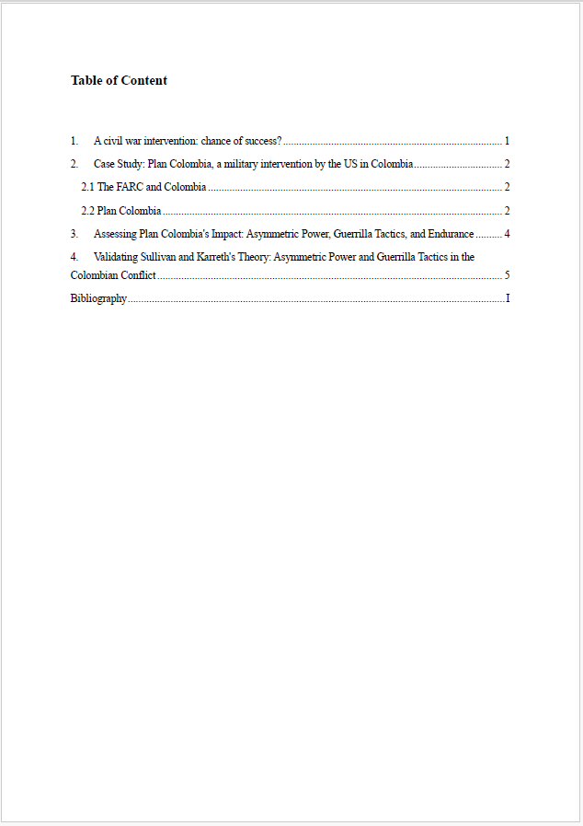
The table of Contents is not mentioned in the Table of Contents itself

Use the word function to design the Table of contents
You can find it under:
- References
- Table of Content
- Choose a Design
- Update your Table of Content regularly, it won’t happen automatically

Your bibliography and similar elements should be part of your Table of Content, but not numbered

No page number on the Table of Contents
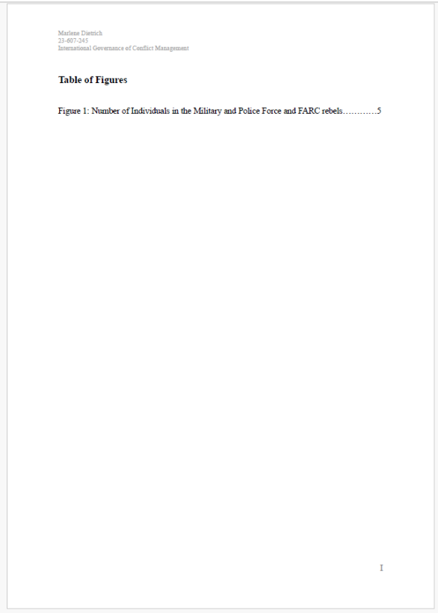

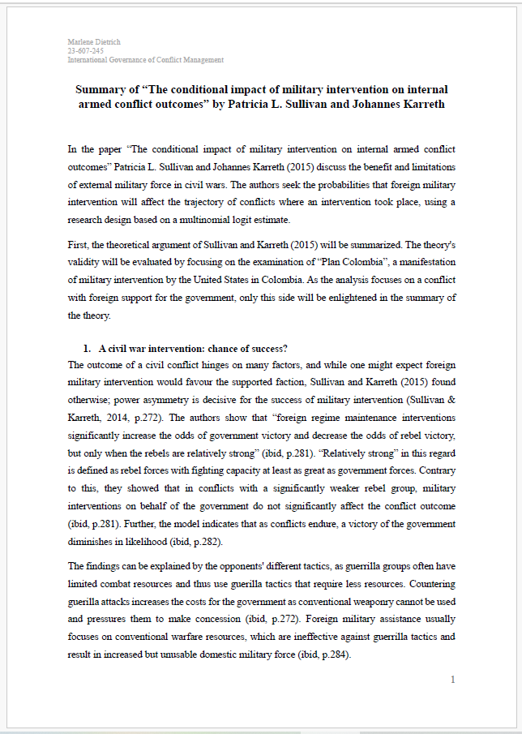
Please start the Arabic numerals when you start your text
Find a good header, normally the name of your paper

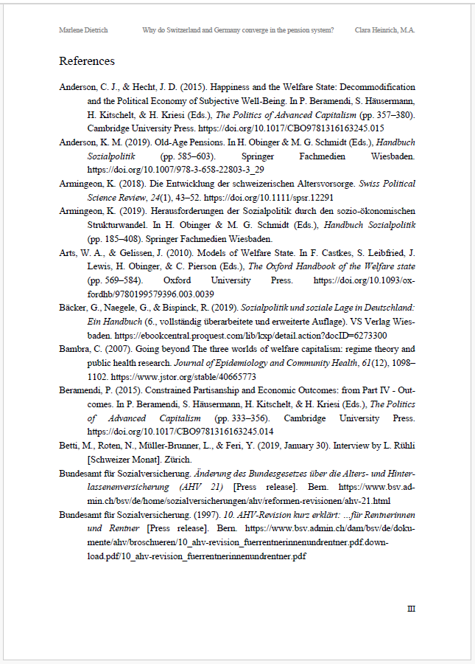
Sort your sources alphabetically
This can be called your List of References, References or Bibliography
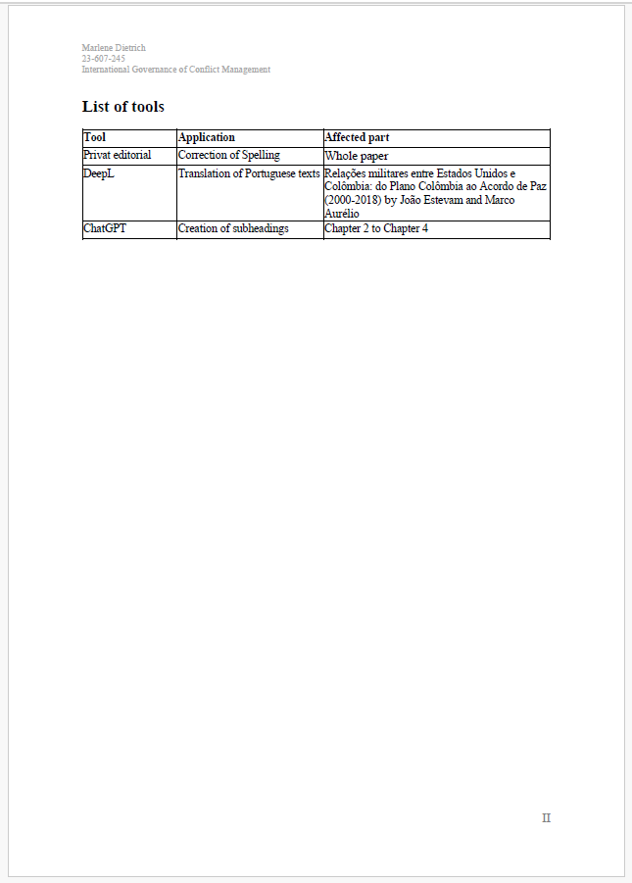

To Do List

Check this to do list before you hand in your work.
- The cover page follows the requirements and contains name, matriculation number and the other information required. You doublechecked everything for spelling errors (see page 29)
- You have a Table of Contents, a Table of Figures, and Table of Abbreviation (if needed)
  - All abbreviations are added to the list
  - You updated your table of contents one last time
- Your paper has font size 11 point with 1.15 spacing, a justified text and the right margins
- Tables and figures are numbered ongoing
- All sources follow APA citation style
  - All direct quotes are cited with a page number
  - Every statement is cited, enough quotes per paragraph where you link your work to extant literature, but avoid over-citation
  - Every source that is cited is in the bibliography
  - Footnotes are correctly numbered
  - References are sorted alphabetically
- Declaration of Authorship is signed and added
- No use of verb tense or personal language.

Final Remarks

It is important to note that the rules are meant to be supportive rather than restrictive.

This guideline is adapted from the guidelines of the Department of Communication and Media Research, who generously provided their document as a foundation. We sincerely appreciate their support.
It should be noted, however, that while this work can serve as a model in formal terms (margins, line spacing, placement of footnotes, etc.), it does not meet the content-related requirements of a scholarly work as a guide. In addition to accurately presenting facts, a scholarly work is expected to include independent arguments and justifications.
DOI (Digital Object Identifier) is an alphanumeric string used for the unique and permanent identification of digital objects. Learn more here or here.

